Monday: State the x- & y-intercepts of the function. 1. −x – y = $\frac{1}{2}$ x-int = ___________ y-int = ____________

Write an equation in point-slope form & slope-intercept form for each line.
2. passes through (–5, 6), slope = 3 3. passes through (6, –6), slope = 5 4. passes through (0, 1) and (2, 5)

5. Write the point-slope form of an equation for the line graphed. 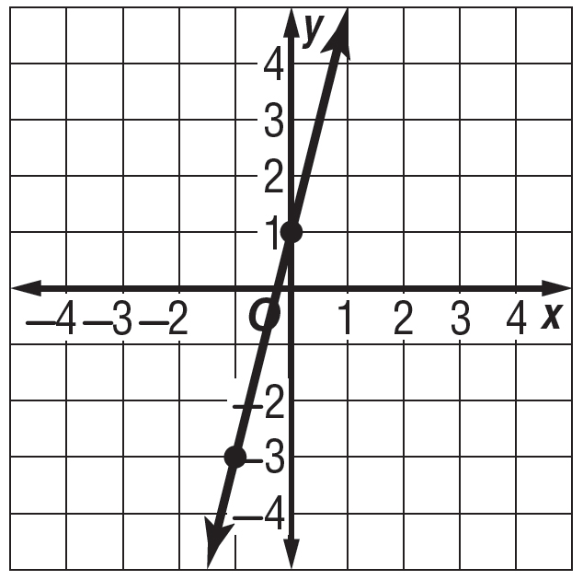

6. TEMPERATURE The table shows the temperature at certain hours. Assuming the temperature change is linear, write
an equation in point-slope form to represent the temperature y at x hour.
Hour | Temperature  (°F)
1 | 35
2 | 39

Tuesday: Write an equation in point-slope form & slope-intercept form for each line.

1. passes through (–5, 9) and (1, 3) 2. passes through (1, –1) and (2, 0) 3. passes through (–3, –5), slope = 2

4. Write the point-slope form of an equation for each line graphed. 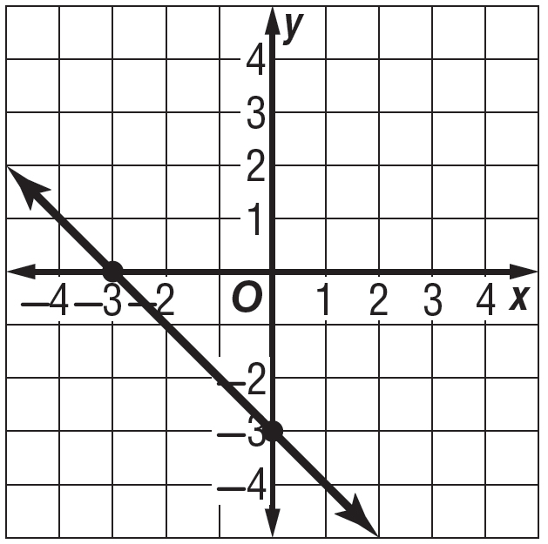

5. SPEED After 2 hours, a car travels 70 miles. After 2.25 hours in the same trip, the car travels 78.75 miles. Write an
equation in point-slope form to represent the distance y of the car after x hours.

Thursday: Solve each system of equations by graphing.
1. y = 3x + 4 2. y = 10 + 6x
y = -x – 4 y = 6x

Write and solve a system of equations that represents each situation. Interpret the solution.
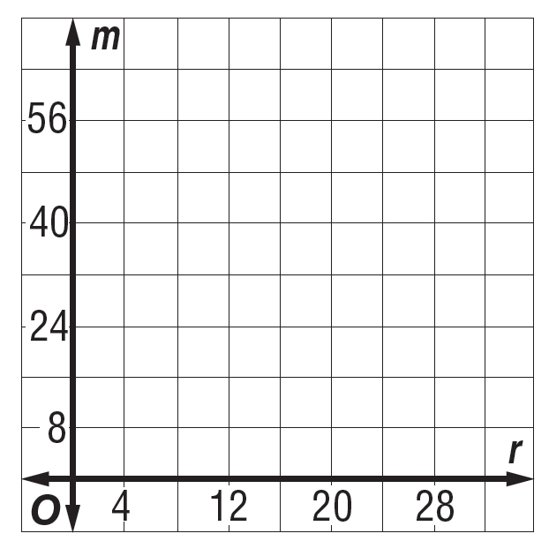
3. BASKETBALL Alonzo and Miguel scored a total of 54
points in the basketball game. Miguel scored four more
points than Alonzo.

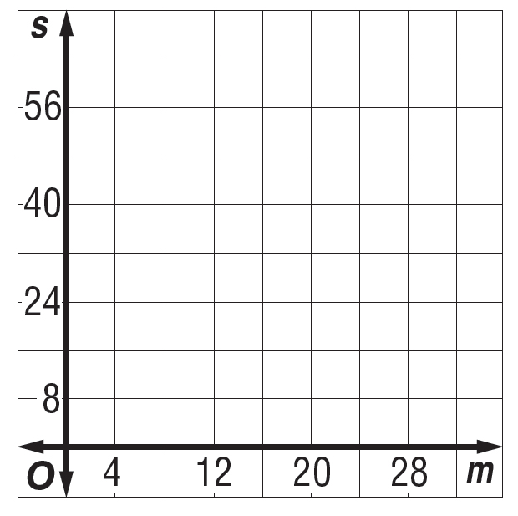
4. AGES Morgan is 15 years younger than Mrs. Santos. Their
combined age is 44.

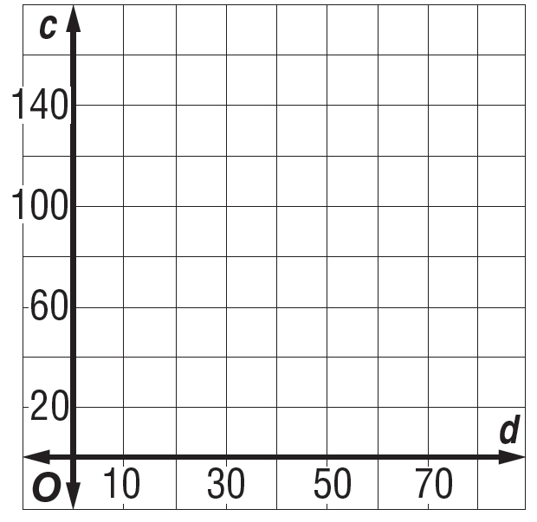
5. ANIMALS The total number of cats and dogs at the shelter
is 125. There are 5 more cats than dogs.

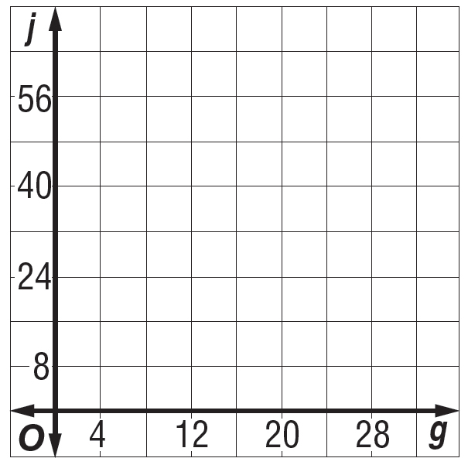
6. PING-PONG Jenny won the ping-pong championship
eight more times than Gerardo. They have won a
combined total of 32 championships.

